9.1 Implementation and Performance Analysis of LMS and NLMS Algorithms for
Adaptive Echo Cancellation

CODING:
clc;
clear;
close all;

%% Generate Input Signal
x = randn(1,1000);

%% Generate Echo Signal
d = filter([0.8 0.5 0.3], 1, x);

%% Create LMS and NLMS Output/Error Signals

N = length(x);

% Parameters
mu_lms = 0.01; % LMS step size
mu_nlms = 0.5; % NLMS step size
M = 3; % Adaptive filter length

% Initialize weights
w_lms = zeros(M,1);
w_nlms = zeros(M,1);

% Initialize error signals
e1 = zeros(1,N);
e2 = zeros(1,N);

% Small constant to avoid division by zero
epsilon = 1e-6;

%% LMS and NLMS Algorithms

for n = M:N

% Input vector
u = x(n:-1:n-M+1)';

%% LMS
y_lms = w_lms' * u;
e1(n) = d(n) - y_lms;

% Update LMS weights
w_lms = w_lms + mu_lms * e1(n) * u;

%% NLMS
y_nlms = w_nlms' * u;
e2(n) = d(n) - y_nlms;

% Update NLMS weights
w_nlms = w_nlms + ...
(mu_nlms / (epsilon + u'*u)) * e2(n) * u;

end

%% Figure 1: Input and Echo Signal

figure;

plot(x, 'b', 'LineWidth', 1.2);
hold on;

plot(d, 'r', 'LineWidth', 1.2);

grid on;

legend('Input', 'Echo');

title('Input and Echo Signal');

xlabel('Sample Number');
ylabel('Amplitude');

hold off;

%% Figure 2: LMS Output

figure;

plot(e1, 'r', 'LineWidth', 1.2);

grid on;

title('LMS Output');

xlabel('Sample Number');
ylabel('Error');

%% Figure 3: NLMS Output

figure;

plot(e2, 'b', 'LineWidth', 1.2);

grid on;

title('NLMS Output');

xlabel('Sample Number');
ylabel('Error');

%% Calculate Moving MSE

window = 50;

mse_lms = movmean(e1.^2, window);
mse_nlms = movmean(e2.^2, window);

%% Figure 4: MSE Comparison

figure;

semilogy(mse_lms, 'r', 'LineWidth', 1.5);
hold on;

semilogy(mse_nlms, 'b', 'LineWidth', 1.5);

grid on;

legend('LMS', 'NLMS');

title('MSE Comparison');

xlabel('Sample Number');
ylabel('Mean Square Error');

hold off;

%% Display Final MSE

fprintf('Final LMS MSE = %.6f\n', mean(e1(end-99:end).^2));
fprintf('Final NLMS MSE = %.6f\n', mean(e2(end-99:end).^2));

OUTPUT:
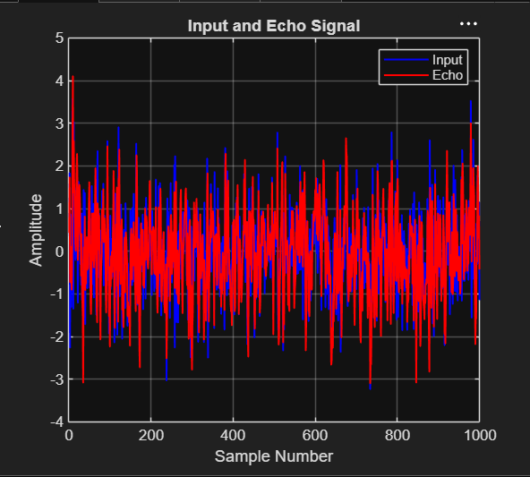
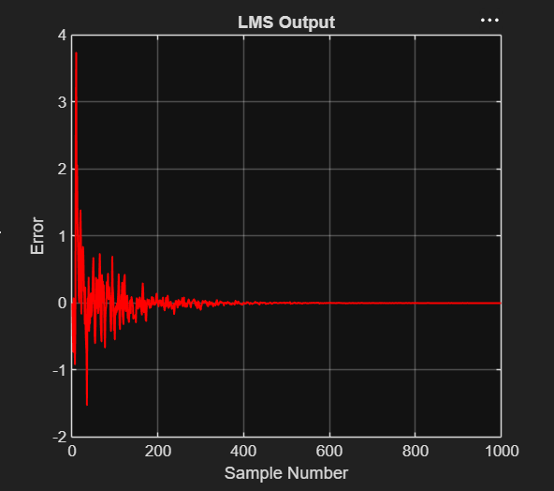
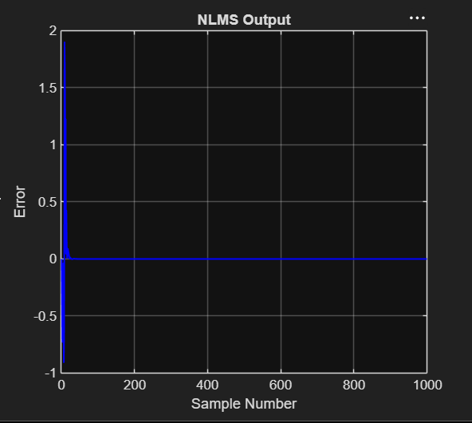
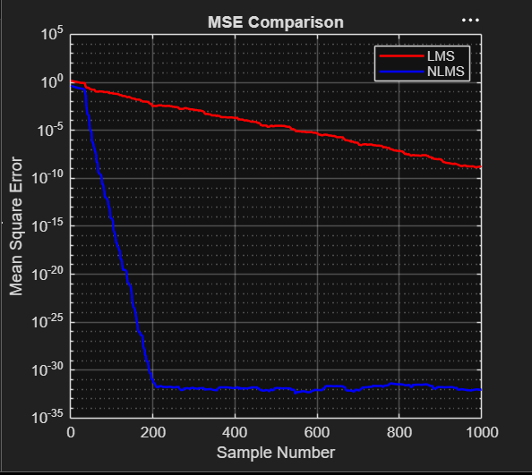

RESULT:
Final LMS MSE = 0.000000
Final NLMS MSE = 0.000000
>>

